INDIAN RAILWAYS TECHNICAL SUPERVISORS ASSOCIATION
(Estd. 1965, Regd. No.1329, Website http://www.irtsa.net )
M. Shanmugam, Central President,
# 4, Sixth Street, TVS Nagar, Padi, Chennai- 600050. Email- cpirtsa@yahoo.com
Mob: 09443140817
Harchandan Singh,
General Secretary, IRTSA,
C.Hq. 32, Phase 6, Mohali,
Chandigarh-160055.
Email-gsirtsa@yahoo.com
(Ph:0172-2228306, 9316131598)
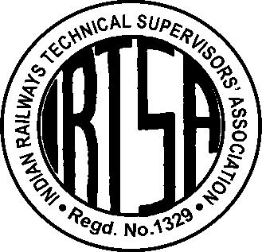

No. IRTSA/ Memo/RB/ 25-C Dated: 22.10.2009

- Chairman, Railway Board, Rail Bhavan, New Delhi
- Member Staff, Railway Board, Rail Bhavan, New Delhi
Dear Sir,
Subject: Revised Classification & mode of filling up non-gazetted posts-
- Reg: Reduction in Percentage of Direct Recruitment in Merged Grades after Sixth CPC –
- To maintain quantum of net direct induction as in Pre- Revised Scales.
Reference: Railway Board’s letter No. E(NG)I-2008/PM1/15 dated 3.9.2009
In continuation of our memorandums dated 10.8.2009 & 8.9.2009, we request the Railway Board to please consider following submissions in regard to the Board’s letter cited above:
- Request for clarity & mionor modification of Para 2.3 (i) & 2.3 (ii) of Board’s letter:
a) Following line may please be added at the end of Para 2.3 (i) of Railway Board’s letter for greater clarity:
2.3 (i) 25% of promotional posts of JE in the grade pay of Rs.4200 in the cadre of Technical Supervisors shall be filled up by “Suitability with Bench Mark”.
b) Para 2.3 (ii) may please be modified to read as under in the interest of justice and for greater clarity - in line with the Annexure enclosed with Board’s letter cited above:
2.3 (ii) Similarly, to fill up the posts of Senior Section Engineers in grade pay Rs. 4600, 29 % posts of the total cadre of Technical Supervisors shall be filled up by 80% promotees with prescribed benchmarks as per para 2 (b) and remaining 20% posts (of these 29% of the total cadre of Technical Supervisors) shall be filled up by direct recruits as per the existing practice by direct recruits
2. Engineering Graduate / Post Graduates in Science Entry Grade in Chemical and Metallurgical Wing & their Redesignation
Para 3.4.7 of Sixth Pay Commission clearly provides as under:
‘all posts in Subordinate engineering cadres carrying minimum qualifications of a degree in engineering and having an element of direct recruitment should be placed in the running Pay Band PB-2 of Rs.8700-34800 along with the grade pay of Rs.4600 corresponding to the pre-revised pay scale of Rs.7450-11500.’
It is therefore, requested that:
i) Incumbents in the pre-revised scale of CMA (Chemical & Metallurgical Assistant-I) who are either direct recruits with Engg. Degree / PG in Science or promotees with Graduation in Science may please be placed in the grade pay of Rs.4600 as CMS (Chemical & Metallurgical Superintendent);
ii) Incumbent CMAs - who are not Science Graduates - may please be considered for balance / future vacancies of CMS after they qualify a Test - which may especially be prescribed by the RDSO - for promotion to the post of CMS.
iii) In future, Direct recruitment of Engineering Graduates/PGs in Science(MSc) may be done for the post of CMS only in line with the Technical Supervisors and as per recommendations of Sixth Pay Commission vide Para 3.4.7 cited above.

3. Drawing and Design Staff
There is 100% direct recruitment of Junior Engineers in Drawing and Design offices in the Grade pay of Rs.4200 with the qualification of Diploma in Engineering and 18 months on-job training. Considering the similarities of the initial qualification, training, knowledge, Job requirements & same Designations etc, the procedure for Direct Recruitment in the Grade Pay of Rs.4600, it is requested that the procedure for filing of Posts of SSE (Drawing and Design) may please be made similar to that of Technical Supervisors as mentioned in 2.3 ii) of Board’s letter cited above with such modification as proposed for Technical Supervisors in our memorandum of even no. dated 8.9.2009
4. Implementation of Panels already approved:
- It is requested that Panels approved on or before 31.08.2009 and current on that date may please be operated first.
- Balance vacancies may please be filled up in the manner prescribed in the statement annexed with Board’s letter dated 3.9.2009 cited above.
5. Employees who retired / resigned between 1.1.2006 and 31.8.2009
Employees who had retired / resigned in between 1.1.2006 and 31.8.2009 may please be considered as eligible for promotion and the fixation benefits and arrears under these orders may please be paid to them if they come under the zone of vacancies – as per provisions of Board’s order under reference.
6. Posts which required joining the promoted post at a different station:
In cases where due to pin-pointing of posts staff is required to join the promoted post at a different station, such staff may please be allowed the benefit of promotion on “as is where is basis” for the time being and allowed to join the pin-pointed post at the new station within six months from the date of issue of promotion orders.
7. Counting of Temporary posts
Temporary posts which are in operation for three years or more may please be taken into account for the purpose of calculating the vacancies & filling up as per mode prescribed by the Railway Board.
8. Revised Designations of Merged Grades:
Revised Designations of merged scales may please be notified early to clearly indicate the posts to which the promotions are to be made.
Hoping for an early and favourable consideration and thanking you in anticipation,
Yours sincerely,
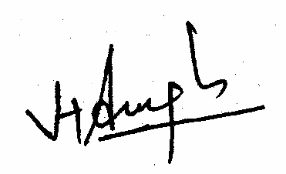
(Harchandan Singh),
GS, IRTSA
Copy for information & necessary action to:
- Advisor Staff, Railway Board, Rail Bhavan, New Delhi
- Shri A. K. Nigam, Advisor Industrial Relations), Railway Board, Rail Bhavan, New Delhi.
- Secretary (Establishment), Railway Board, Rail Bhavan, New Delhi
- Executive Director Pay Commission, Railway Board, Rail Bhavan, New Delhi.

