INDIAN RAILWAYS TECHNICAL SUPERVISORS ASSOCIATION
(Estd. 1965, Regd. No.1329, Website http://www.irtsa.net )
M. Shanmugam, Central President,
# 4, Sixth Street, TVS Nagar, Chennai- 600050.
Email- cpirtsa@yahoo.com
Mob: 09443140817
No. IRTSA/ Memo/RB/ 25-09 Dated 10. 8. 2009
Harchandan Singh,
General Secretary, IRTSA,
C.Hq. 32, Phase 6, Mohali,
Chandigarh-160055.
Email-gsirtsa@yahoo.com
(Ph:0172-2228306, 9316131598)
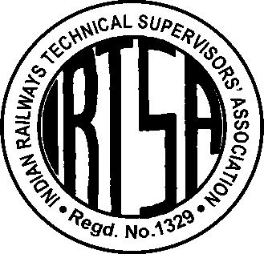

- Chairman, Railway Board, Rail Bhavan, New Delhi
- Member Staff, Railway Board, Rail Bhavan, New Delhi

Dear Sir,
Subject: Reduction in % age of Direct Recruitment in Merged Grades after Sixth CPC –
- To maintain quantum of net direct induction as in Pre-Revised Scales.
Reference: Railway Service (Revised Pay) Rules, 2008 & Schedules for revised Scales of Pay, Annexure-A & B, dated 11th Sept 2008.

1. A number of Pay Scales in different categories have been merged after Sixth Pay Commission thus the combined strength of posts in the merged scale shall be counted for direct recruitment. Thus the total quantum of direct recruitment will proportionately increase at each level if the percentage of Direct Recruitment is retained at the existing level. This will adversely affect the avenues of promotion of the existing staff in the lower scales.
2. In the revised scale Percentage of Direct Recruitment should be determined in such a way that Number of Direct Recruitment should not exceed the pre-SCPC level for any particular cadre. This has to be ensured so that
  - Existing Promotional chances for the servicing employees should not get disturbed.
  - Promotional chances on LDCE should be kept at same level
  - Number of posts filled up through direct recruitment in the Cadre should not be increased by suitably modifying the percentage of Direct Recruitment.
3 a) It is, therefore, requested that the % age of Direct Recruitment of Engineering Graduates in the cadre of Technical Supervisors in the merged scale of Senior Section Engineers (with Grade Rs 4600) may please be kept as 11.5 % (of 47% of posts in the merged strength SE & SSE instead of 20% of 29% posts of SE only) to maintain quantum of net direct induction in Pre-Revised Scales (of Rs 6500-10500).
b) Similarly, it is requested that the percentage of Direct Recruitment where ever existing in other merged grades may also please be proportionately reduced to maintain quantum of net direct induction in Pre-Revised Scales.
Yours’ faithfully,

Harchandan Singh,
General Secretary, IRTSA
Copy for information & necessary action to:
- Secretary (Establishment), Railway Board, Rail Bhavan, New Delhi
- Executive Director Pay Commission, Railway Board, Rail Bhavan, New Delhi.
- Advisor Industrial Relations) , Railway Board, Rail Bhavan, New Delhi.

